Research Based Project

Algorithm Lab (CSE215)

Bus Ticket Booking System

Our project is based on Bus Ticket Booking system.

In this project. we will add some feature like one can book any seat of their choice if available but if the seat has already been reserved by someone else then our system will inform it to the user and it will suggest them to choose another one by showing

“WE are sorry Sir/Ma’am The seat you are looking for isn’t available . Please choose another one from these vacant seats.

Thank you. have a nice day.”

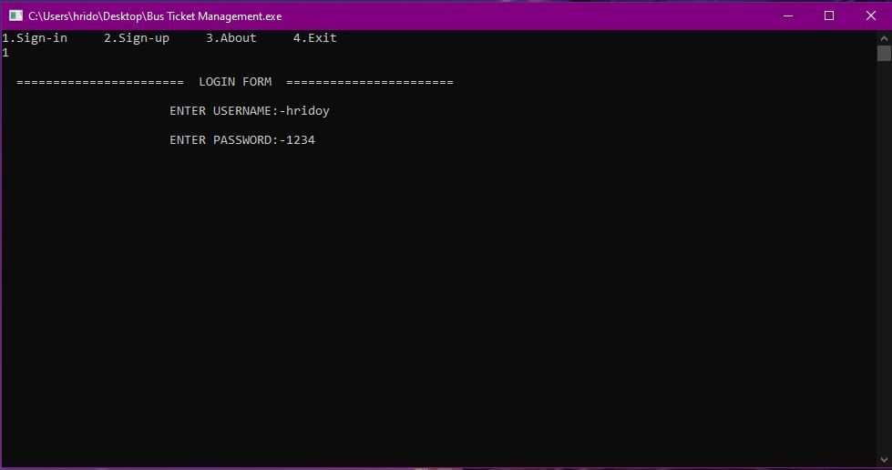

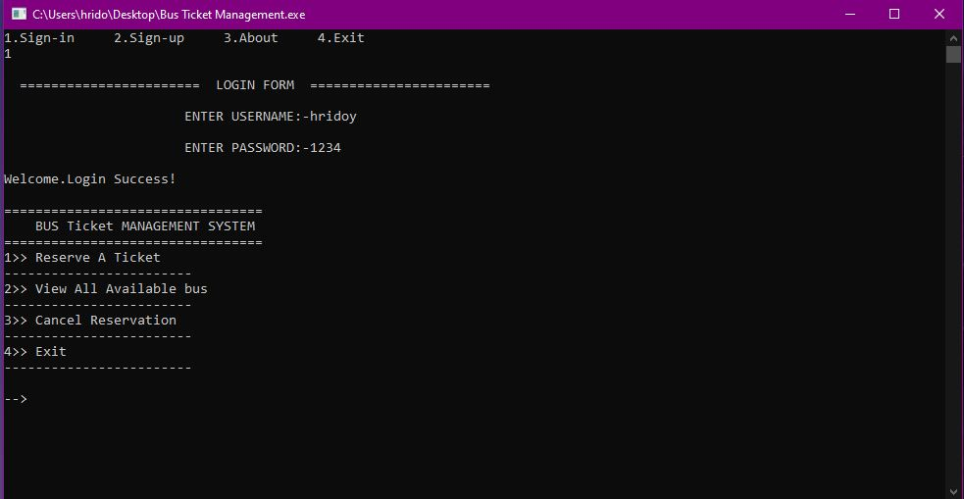

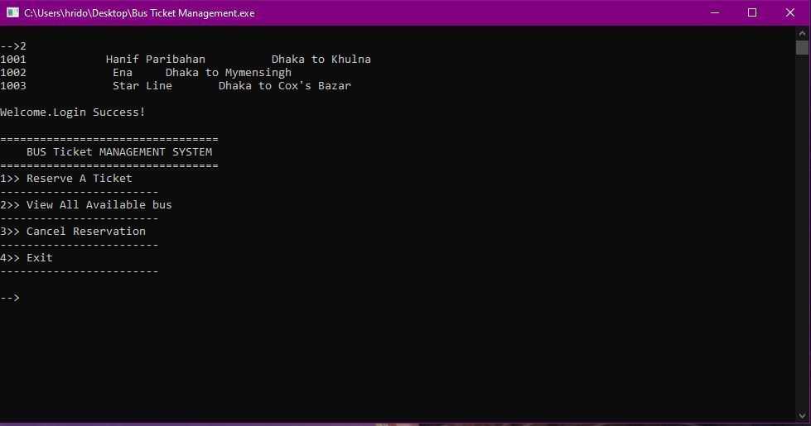

Group Member

|  |  |  |  |
| --- | --- | --- | --- |
| NO. | NAME | MAIL | ID |
| 01 | Arif Billah Bhuiyan | arif15-12904@diu.edu.bd | 191-15-12904 |
| 02 | Rashedur Rahman Hridoy | rashedur15-12882@diu.edu.bd | 191-15-12882 |
| 03 | Adnan Ashkari | adnan15-12710@diu.edu.bd | 191-15-12710 |
| 04 | Jamal Hossan Bhuiyan | jamal15-12977@diu.edu.bd | 191-15-12977 |
| 05 | Tahmid Islam | tahmid15-12899@diu.edu.bd | 191-15-12899 |
| 06 | Nazib Hossain | mohammad15-11971@diu.edu.bd | 183-15-11971 |